**DAILY ONLINE ACTIVITIES SUMMARY**

|  |  |  |  |  |  |  |  |  |
| --- | --- | --- | --- | --- | --- | --- | --- | --- |
| **Date:** | **31-05-2020 &**  **30-05-2020** | | | | | **Name:** | **Shashaikant Chavan** | |
| **Sem & Sec** | **8th sem B sec** | | | | | **USN:** | **4AL16CS090** | |
| **Online Test Summary** | | | | | | | | |
| **Subject** | | **IOT** | | | | | | |
| **Max. Marks** | | **20** | | **Score** | | | **26** | |
| **Certification Course Summary** | | | | | | | | |
| **Course** | **Ethical Hacking** | | | | | | | |
| **Certificate Provider** | | | **Great learning website** | | **Duration** | | | **6 hrs** |
| **Coding Challenges** | | | | | | | | |
| **Problem Statement:**  1)write a c program to sort an array of integers in ascending or descending order and display the sorted array and number of passes performed for sorting | | | | | | | | |
| **Status: completed** | | | | | | | | |
| **Uploaded the report in Github** | | | | | **yes** | | | |
| **If yes Repository name** | | | | | **Shashikant_chavan** | | | |
| **Uploaded the report in slack** | | | | | **yes** | | | |

Online Test Details: (Attach the snapshot and briefly write the report for the same)

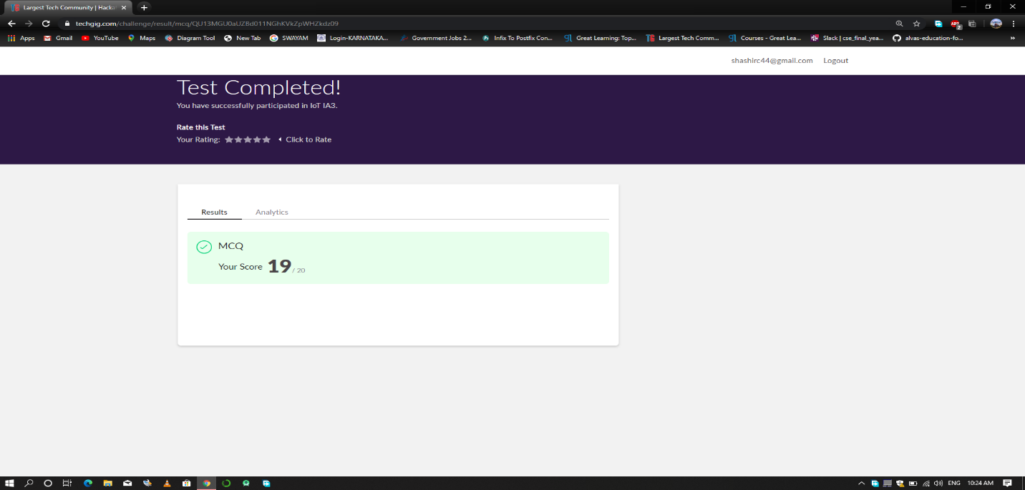

Certification Course Details: (Attach the snapshot and briefly write the report for the same)

Completed Ethival Hacking Course

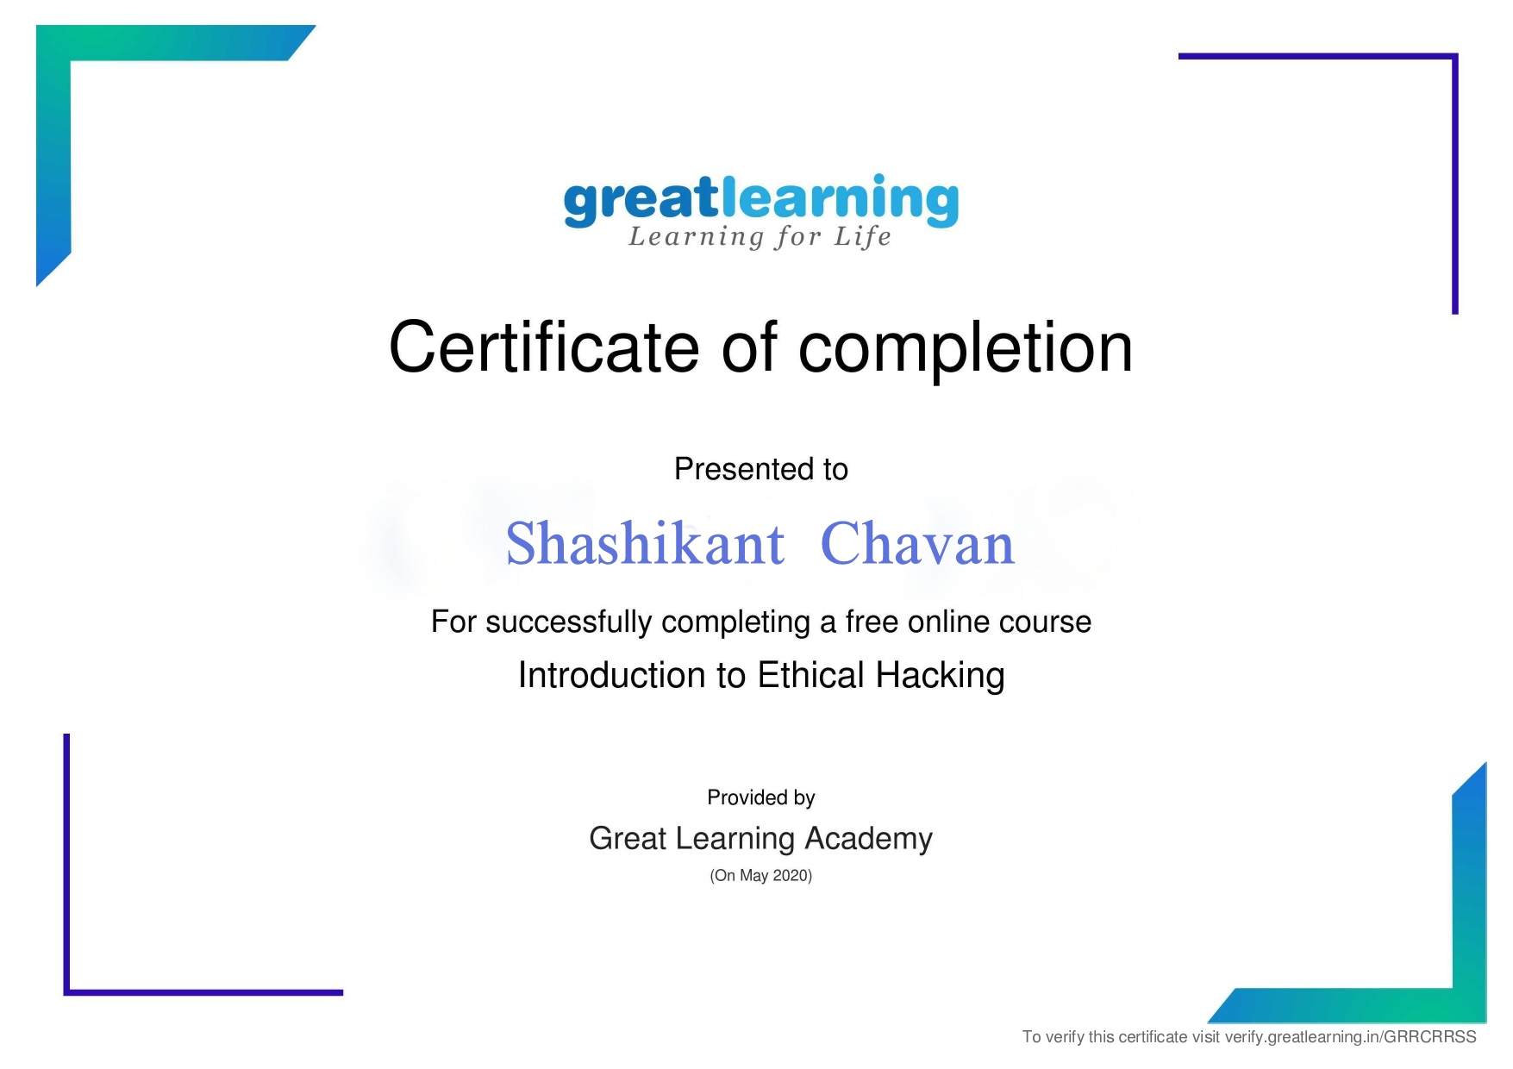

Coding Challenges Details: (Attach the snapshot and briefly write the report for the same)

Coding was given n it was uploaded for github and slack

PROGRAM1

#include stdio.h

void swap(int *xp, int *yp)

{

int temp = *xp;

*xp = *yp;

*yp = temp;

}

int bubbleSort(int arr[], int n)

{

int i, j,count=0;

int swapped;

for (i = 0; i < n-1; i++)

{

swapped = 0;

for (j = 0; j < n-i-1; j++)

{

if (arr[j] > arr[j+1])

{

swap(&arr[j], &arr[j+1]);

swapped = 1;

count++;

}

}

if (swapped == 0)

break;

}

return count;

}

void printArray(int arr[], int size)

{

int i;

for (i=0; i < size; i++)

printf("%d ", arr[i])

printf("\n");

}

int main()

{

int arr[50],num;

printf("enter the number of elements");

scanf("%d",&num);

printf("enter the elements");

for(int i=0;i=n;i++)

}